# **Assignment 3**

Q1: (25 Marks)

The Breadth First Search algorithm, as given in the text book and studied in the class, assumes that the graph is represented as an Adjacency List.

Write modified BFS pseudo-code as if the graph is represented as Adjacency Matrix. Also derive it’s Asymptotic Time Complexity.

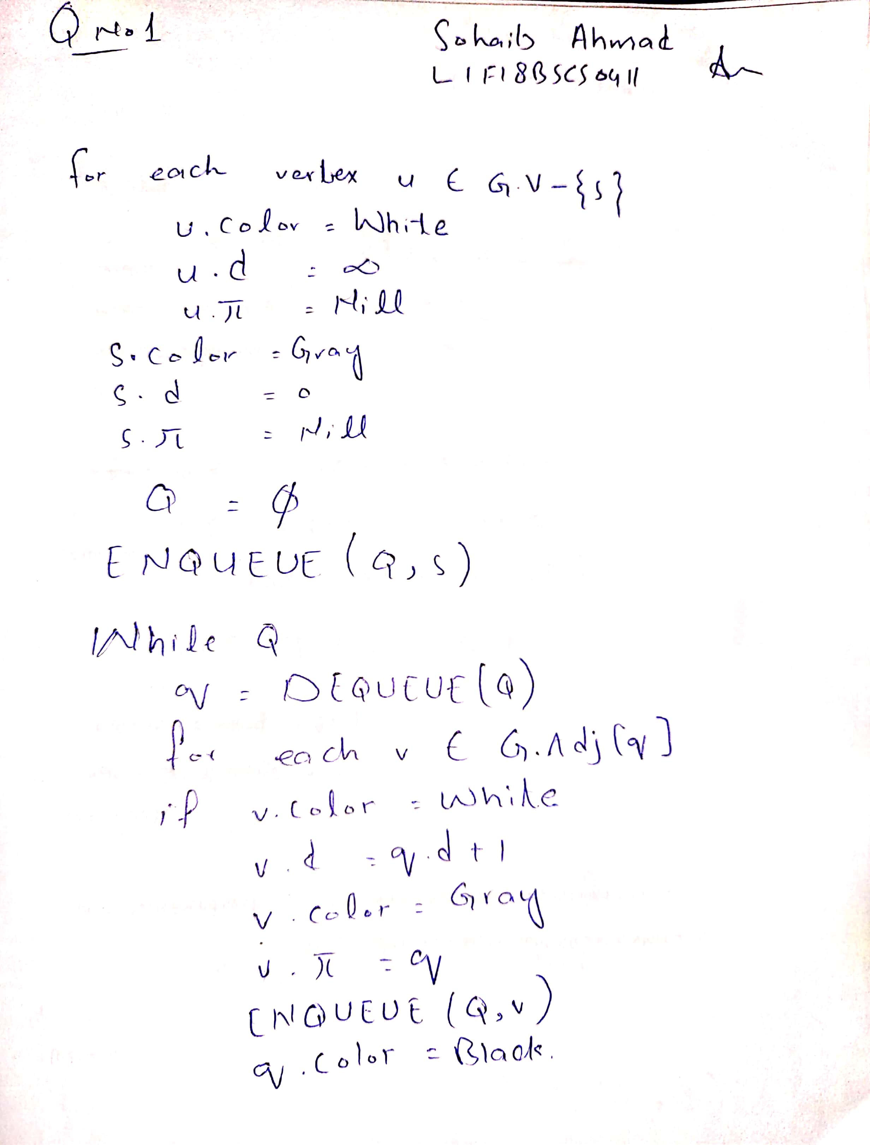

Q2: (15 Marks)

Modify the BFS pseudo-code, on the lines of DFS so that it covers the entire graph even if the graph is not connected.

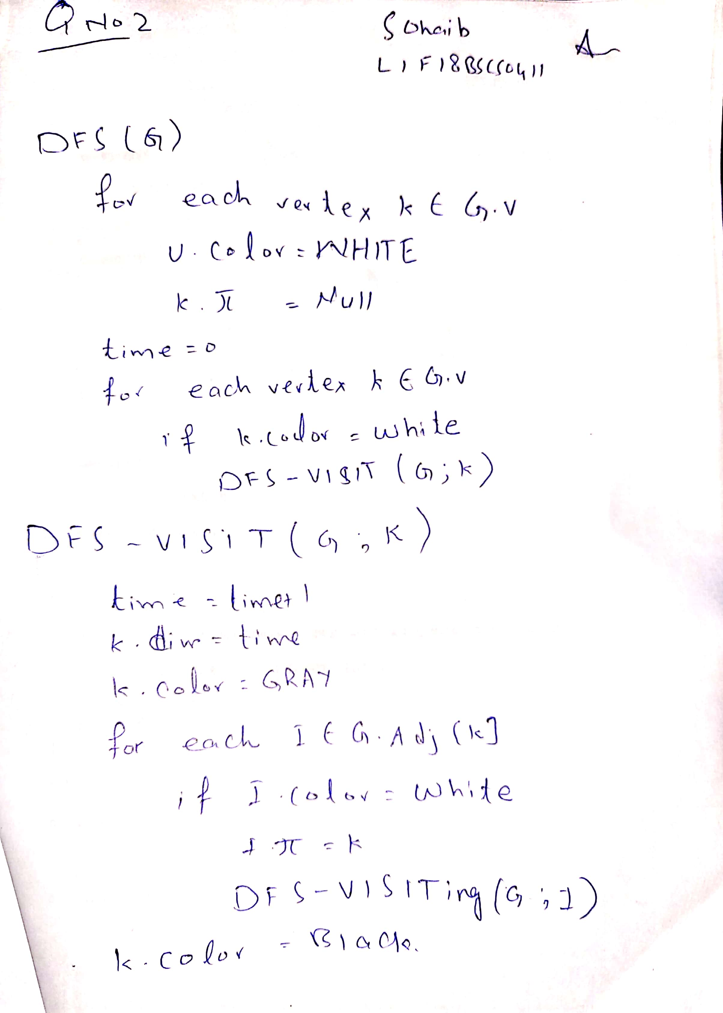

Q3: (25 Marks)

Write a program in pseudo-code to print all paths between two given vertices, u and v, of a directed, connected graph.

Briefly explain your algorithm first and then write the program.

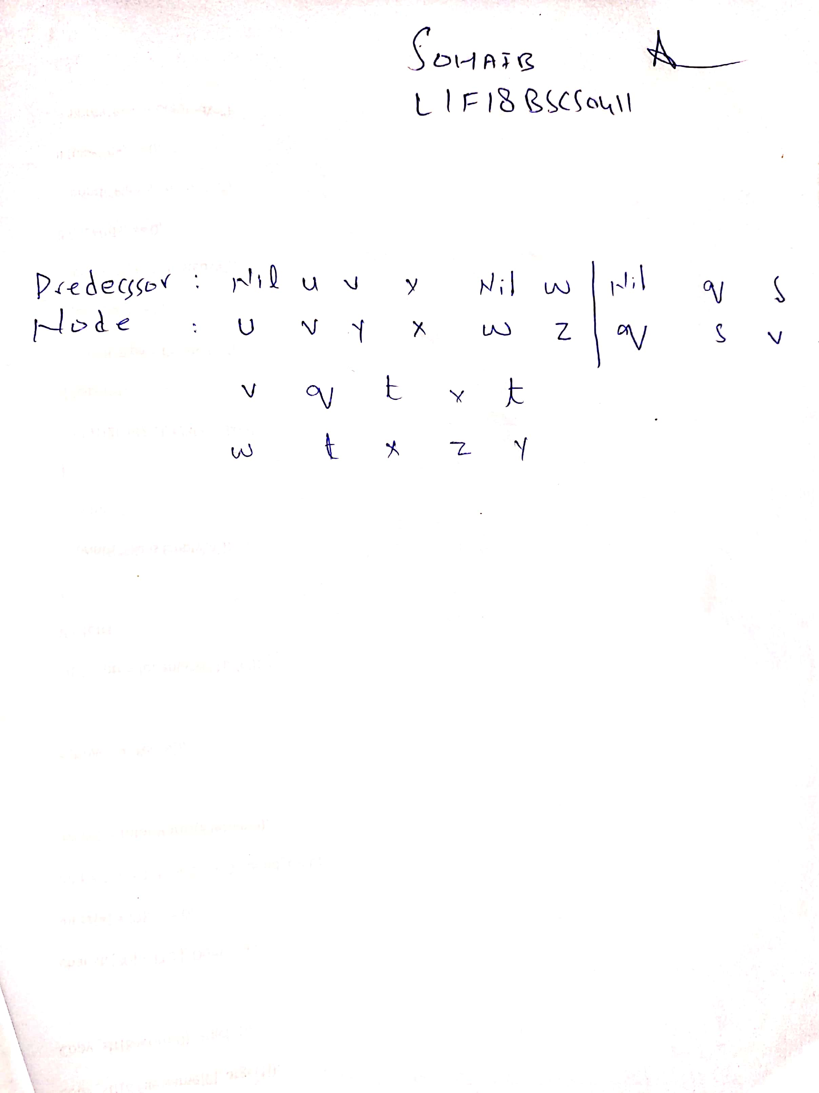

Q4: (25 Marks)

Write a program in pseudo-code that tells the existence of a path between every pair of vertices of a given directed graph.

The program does not need to tell the actual path, only the existence.

Briefly explain your algorithm first and then write the program.